1.What is semantic network? Illustrate the semantic network representation of the following information

Tom is a cat.

Tom caught a bird.

Tom is owned by John.

Tom is ginger in colour

. Cats like cream.

The cat sat on the mat.

A cat is a mammal

. A bird is an animal.

All mammals are animals.

Mammals have fur

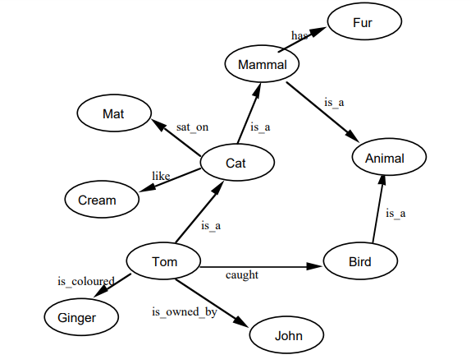

***************************************************************************************

Tom is an instance of dog.

Tom caught a cat

Tom is owned by roshan.

Tom is brown in colour.

Dogs like bones.

The dog sat on the mat.

A dog is a mammal.

A cat is an instance animal

All mammals are animals.

Mammals have fur.

A semantic network is a graphical representation of relationships among concepts. It consists of nodes, which represent concepts or entities, and edges, which represent relationships between these concepts. Semantic networks are used to organize and represent knowledge in a structured and interconnected manner.

Now, let's illustrate the semantic network representation of the provided information:

- **Nodes**: Concepts or entities

- **Edges**: Relationships between concepts

Here's the semantic network representation:

```

In this representation:

- **Tom** is connected to:

- **Caught** (action)

- **Owned by Roshan** (ownership)

- **Brown in color** (property)

- **Dog** is connected to:

- **Likes** (preference)

- **Sat on the mat** (location)

- **Has fur** (attribute)

- **Is a mammal** (classification)

- **Cat** is connected to:

- **Is an instance animal** (classification)

- **Mammal** is connected to:

- **Is an animal** (classification)

- **Has fur** (attribute)

- **All mammals** is connected to:

- **Animal** (classification)

This semantic network captures the relationships among the concepts provided in the information, illustrating how they are interconnected and related to each other.

2.Write short note on conflict resolution.

Conflict resolution is the process of addressing and resolving disputes or disagreements between individuals or groups in a constructive and peaceful manner. It aims to find mutually acceptable solutions that satisfy the interests of all parties involved while minimizing hostility and fostering positive relationships. Here are key points to consider in conflict resolution:

1. **\*\*Identification of the Conflict**:** The first step in resolving any conflict is to identify and understand its nature, causes, and underlying issues. This requires open communication and active listening to all parties involved.

2. **\*\*Communication**:** Effective communication is essential for resolving conflicts. All parties should express their concerns, perspectives, and feelings in a respectful and non-confrontational manner. Clear and open communication helps in finding common ground and exploring potential solutions.

3. **\*\*Active Listening**:** Active listening involves paying full attention to what others are saying without interrupting or passing judgment. It helps in understanding the underlying interests and emotions driving the conflict, leading to better problem-solving and resolution.

4. **\*\*Empathy and Understanding**:** Empathy involves putting oneself in the shoes of others and understanding their perspectives, emotions, and needs. Showing empathy helps in building trust and rapport, creating a conducive environment for resolving conflicts collaboratively.

5**. **Negotiation and Compromise**:** Negotiation involves a give-and-take process where parties work together to find mutually acceptable solutions. It often requires compromise and flexibility from all parties involved. Win-win solutions that address the interests of both sides are generally more sustainable in the long run.

6. **\*\*Problem-Solving**:** Conflict resolution involves problem-solving techniques to address the root causes of the conflict and prevent its recurrence. This may involve brainstorming, exploring alternatives, and seeking creative solutions that meet the needs and interests of all parties.

7. **\*\*Mediation and Third-Party Intervention**:** In some cases, impartial mediators or third parties may facilitate the resolution process by providing a neutral perspective, facilitating communication, and guiding the parties towards a mutually agreeable solution.

8**. **Conflict Resolution Strategies**:** Various conflict resolution strategies exist, including collaboration, compromise, accommodation, avoidance, and competition. The most appropriate strategy depends on the nature of the conflict, the relationship between the parties, and the desired outcomes.

Overall, effective conflict resolution requires patience, empathy, communication, and a willingness to work towards mutually beneficial solutions. By addressing conflicts constructively, individuals and organizations can foster positive relationships, enhance teamwork, and promote a culture of collaboration and mutual respect.

3.Detail any five advantages of a production system for Al.

A production system is a type of cognitive architecture for implementing search algorithms and simulating human problem-solving abilities. This problem-solving knowledge is stored in the system in the form of products, which are little quanta.

Here are five key advantages of using a production system for AI:

**1. Modularity:** Production systems are highly modular, meaning individual rules can be added, removed, or modified independently. This makes them easy to maintain, update, and adapt to changing needs or new information. This modularity also simplifies troubleshooting and identifying the source of errors.

**2. Transparency and Explainability:** Production systems use explicit rules, making their reasoning process transparent and explainable. This is crucial for understanding how the system arrived at a decision, especially in sensitive applications where trust and accountability are paramount. Unlike some complex AI models like neural networks, production systems offer greater interpretability.

**3. Flexibility and Adaptability:** Production systems are flexible and can handle a wide range of situations and problems. They can be easily adapted to new domains by adding or modifying rules, making them suitable for dynamic environments where the requirements might evolve over time. This flexibility allows for continuous learning and improvement of the system.

**4. Real-time Decision Making:** Production systems are well-suited for real-time applications as they can quickly match incoming data to relevant rules and make decisions efficiently. This makes them ideal for tasks like medical diagnosis, fraud detection, and robotic control.

**5. Knowledge Representation and Sharing:** Production systems provide a clear and structured way to represent knowledge, making it easier to share and collaborate on AI development. This allows domain experts to contribute their knowledge and expertise to the system without needing to be coding experts

**Section-B**

4)Illustrate the working of a Rule based expert system with a suitable example.

A rule-based expert system is a type of artificial intelligence system that uses a set of rules or "if-then" statements to make decisions or solve problems within a specific domain of knowledge. These systems are designed to emulate the decision-making process of human experts by encoding their knowledge into a set of rules.

Here's a simplified example to illustrate the working of a rule-based expert system:

Let's consider a rule-based expert system designed to diagnose medical conditions based on symptoms reported by patients.

**Domain**: Medical Diagnosis

**Rules**:

1. If the patient has a fever and cough, diagnose the patient with the flu.

2. If the patient has a sore throat and swollen lymph nodes, diagnose the patient with tonsillitis.

3. If the patient has a rash and itching, diagnose the patient with an allergic reaction.

4. If the patient has difficulty breathing and wheezing, diagnose the patient with asthma.

**Working of the Expert System**:

1. **Input**: The system takes input in the form of symptoms reported by the patient during a consultation.

2. **Matching Rules**: The system matches the reported symptoms with the conditions specified in the rules.

3. **Inference Engine**: Based on the matching rules, the system's inference engine selects the appropriate actions or conclusions.

4. **Output**: The system provides a diagnosis or recommendation based on the matched rules.

**Example Scenario**:

Suppose a patient presents the following symptoms during a consultation:

- Fever

- Cough

**Working of the System**:

1. The system matches the reported symptoms with the rules.

2. It finds that the symptoms match the first rule: "If the patient has a fever and cough, diagnose the patient with the flu."

3. The inference engine selects the conclusion from the matched rule.

4. The system outputs the diagnosis: "The patient likely has the flu."

In this example, the rule-based expert system uses a set of rules to analyze symptoms and provide a diagnosis. The system's strength lies in its ability to process information based on explicit rules and make decisions consistent with the knowledge encoded within those rules. Rule-based expert systems are widely used in various fields, including medicine, finance, and engineering, to automate decision-making processes and provide expert-level insights and recommendations.

**2) With a neat diagram explain the architecture of Expert system.**

The architecture of an expert system typically consists of several components that work together to enable the system to emulate the decision-making capabilities of human experts. Here's a simplified diagram illustrating the architecture of an expert system:

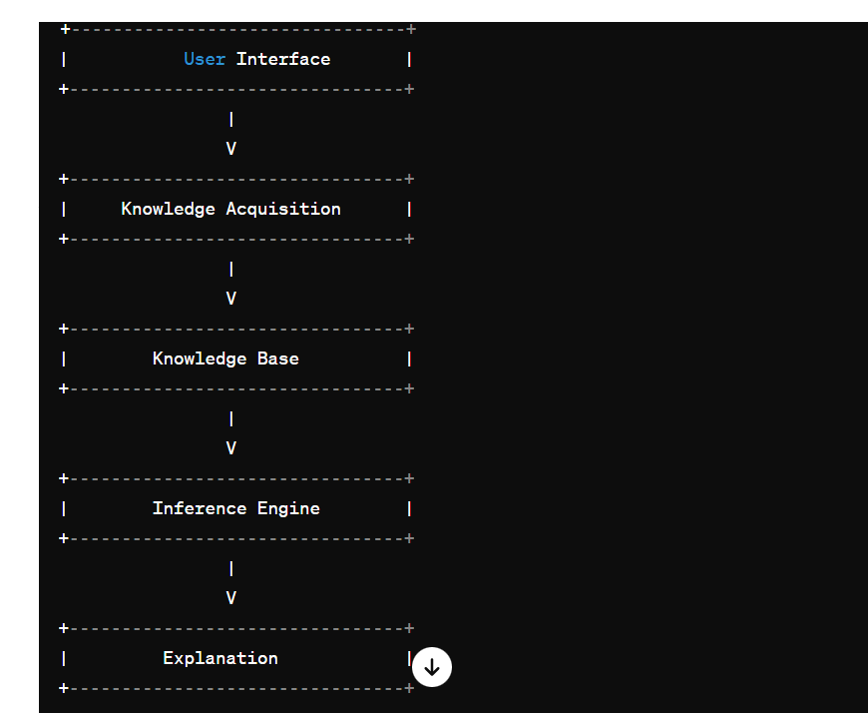

41. **User Interface**:

- This component allows users to interact with the expert system. It provides a means for users to input queries, receive responses, and interact with the system's functionalities.

2. **Knowledge Acquisition**:

- This component is responsible for acquiring knowledge from domain experts and encoding it into a format that the expert system can understand and utilize. Knowledge acquisition methods may include interviews, documentation review, and data analysis.

3. **Knowledge Base**:

- The knowledge base stores the knowledge acquired from domain experts. It consists of a repository of rules, facts, heuristics, and other forms of knowledge representation. The knowledge base serves as the backbone of the expert system, providing the information necessary for decision-making.

4. **Inference Engine**:

- The inference engine is the core component of the expert system responsible for reasoning and decision-making. It applies the rules and knowledge stored in the knowledge base to draw conclusions, make inferences, and generate solutions to problems or queries posed by users.

5. **Explanation**:

- The explanation component provides justification and reasoning behind the decisions made by the expert system. It explains how the system arrived at a particular conclusion or recommendation, helping users understand the rationale behind the system's decisions.

In summary, the architecture of an expert system comprises these key components: the user interface for interaction, knowledge acquisition for acquiring domain knowledge, the knowledge base for storing acquired knowledge, the inference engine for reasoning and decision-making, and the explanation component for providing justification and reasoning. These components work together to enable the expert system to emulate the problem-solving capabilities of human experts in specific domains.

**3) Compare monotonic and non-monotonic reasoning.**

Monotonic and non-monotonic reasoning are two different approaches to logical reasoning used in artificial intelligence and knowledge representation. Here's a comparison between the two:

1. **Monotonic Reasoning**:

- **Definition**: Monotonic reasoning is a form of logical reasoning where the addition of new information never invalidates previously drawn conclusions. In other words, if a conclusion is reached based on a set of premises, adding more premises will not change the validity of the original conclusion.

- **Characteristics**:

- Monotonic reasoning operates under the assumption that the knowledge base is complete and consistent.

- It follows the principle of logical deduction, where conclusions are drawn based on deductive reasoning from given premises.

- Monotonic reasoning is commonly associated with classical logic and formal deductive systems.

- **Example**: If it is known that all humans are mortal, and Socrates is a human, then it can be deduced monotonically that Socrates is mortal.

2. **Non-Monotonic Reasoning**:

- **Definition**: Non-monotonic reasoning is a form of logical reasoning where the addition of new information can lead to the revision or retraction of previously drawn conclusions. It allows for reasoning in the presence of incomplete, inconsistent, or uncertain information.

- **Characteristics**:

- Non-monotonic reasoning is designed to handle incomplete or uncertain information by allowing for defeasible inference.

- It often involves reasoning with default assumptions and dealing with exceptions and contextual changes.

- Non-monotonic reasoning is commonly used in areas such as commonsense reasoning, expert systems, and artificial intelligence.

- **Example**: In a default rule-based system, if birds typically fly, then it can be inferred that Tweety, being a bird, can fly. However, if it is later revealed that Tweety is a penguin, which is a flightless bird, the initial conclusion may be retracted.

**Comparison**:

- **Handling Uncertainty**: Non-monotonic reasoning can handle uncertain and incomplete information, while monotonic reasoning assumes complete and consistent knowledge.

- **Revision of Conclusions**: Non-monotonic reasoning allows for the revision of conclusions based on new information, whereas monotonic reasoning does not revise conclusions based on new premises.

- **Common Usage**: Non-monotonic reasoning is commonly used in expert systems, commonsense reasoning, and AI applications dealing with incomplete or uncertain information. Monotonic reasoning is more aligned with classical logic and formal deductive reasoning.

In summary, while monotonic reasoning relies on the assumption of completeness and consistency, non-monotonic reasoning provides a more flexible approach to reasoning in the presence of uncertainty and incomplete information.